Q. Demonstrate the Static Routing in Packet Tracer.
Aim : To write a code to demonstrate static routing in packet tracer.
Steps:
- In packet tracer take 2 PCs and 2 Routers.
- Connect Router0 with PC0 via fastethernet0/0 using cross-copper cord and Router1 with PC1 via fasethernet0/0 using cross-copper cord.
- Connect both router via fastethernet0/1 using cross-copper cord.
- Set the IP address and default gateway of both the PCs in ip configuration of both the PCs respectively.

Topology:
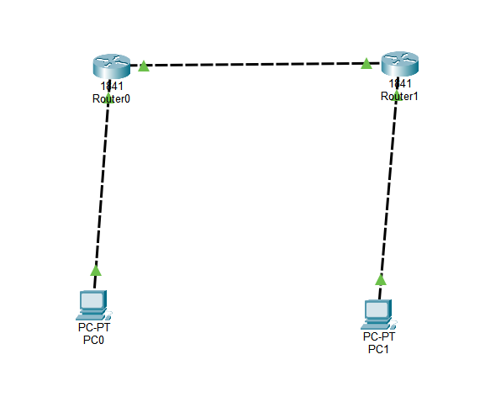
Code:
Router0:
Router> enable
Router# configure terminal
Router(config)# interface fastethernet0/0
Router(config-if)# ip address 10.0.0.1 255.0.0.0
Router(config-if)# no shutdown
Router(config-if)# exit
Router(config)# interface fastethernet0/1
Router(config-if)# ip address 20.0.0.1 255.0.0.0
Router(config-if)# no shutdown
Router(config-if)# exit
Router(config)#ip route 40.0.0.0 255.0.0.0 20.0.0.2 Router(config)#exit Router1:
Router> enable
Router# configure terminal
Router(config)# interface fastethernet0/0
Router(config-if)# ip address 20.0.0.2 255.0.0.0
Router(config-if)# no shutdown
Router(config-if)# exit
Router(config)# interface fastethernet0/1
Router(config-if)# ip address 40.0.0.1 255.0.0.0
Router(config-if)# no shutdown
Router(config-if)# exit
Router(config)#ip route 10.0.0.0 255.0.0.0 20.0.0.1
Router(config)#exit

Verification: In Both PCs Command Prompt.
PC0:
C:\ipconfig
C:\ping 10.0.0.1
C:\ping 10.0.0.2
C:\ping 20.0.0.1
C:\ping 20.0.0.2
C:\ping 40.0.0.1
C\:ping 40.0.0.2
PC1:
C:\ipconfig
C:ping 40.0.0.1
C:ping40.0.0.2
C:ping 20.0.0.2
C:ping 20.0.0.1
C:ping 10.0.0.1
C:ping 10.0.0.2

Output:
PC0:
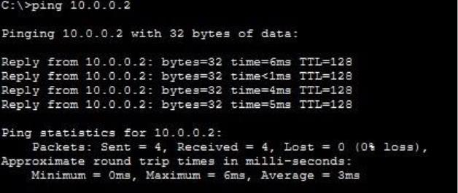
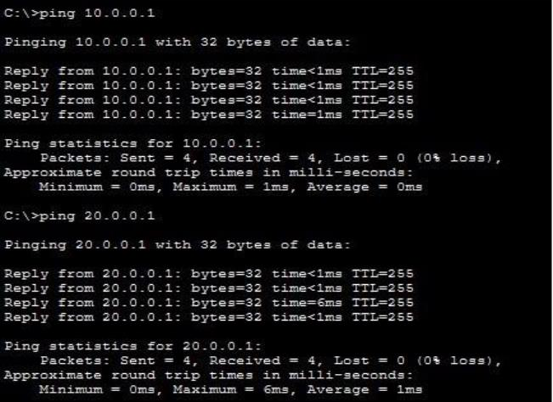
PC1:
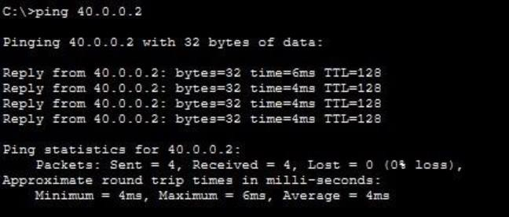
Conclusion:The above Topology has been executed successfully.

